**Tutorial To Implement k-Nearest Neighbors in Python From Scratch**

The k-Nearest Neighbors algorithm (or kNN for short) is an easy algorithm to understand and to implement, and a powerful tool to have at your disposal.

In this tutorial you will implement the k-Nearest Neighbors algorithm from scratch in Python (2.7). The implementation will be specific for classification problems and will be demonstrated using the Iris flowers classification problem.

This tutorial is for you if you are a Python programmer, or a programmer who can pick-up python quickly, and you are interested in how to implement the k-Nearest Neighbors algorithm from scratch.

## What is k-Nearest Neighbors

The model for kNN is the entire training dataset. When a prediction is required for a unseen data instance, the kNN algorithm will search through the training dataset for the k-most similar instances. The prediction attribute of the most similar instances is summarized and returned as the prediction for the unseen instance.

The similarity measure is dependent on the type of data. For real-valued data, the Euclidean distance can be used. Other other types of data such as categorical or binary data, Hamming distance can be used.

In the case of regression problems, the average of the predicted attribute may be returned. In the case of classification, the most prevalent class may be returned.

## How does k-Nearest Neighbors Work

The kNN algorithm is belongs to the family of instance-based, competitive learning and lazy learning algorithms.

Instance-based algorithms are those algorithms that model the problem using data instances (or rows) in order to make predictive decisions. The kNN algorithm is an extreme form of instance-based methods because all training observations are retained as part of the model.

It is a competitive learning algorithm, because it internally uses competition between model elements (data instances) in order to make a predictive decision. The objective similarity measure between data instances causes each data instance to compete to “win” or be most similar to a given unseen data instance and contribute to a prediction.

Lazy learning refers to the fact that the algorithm does not build a model until the time that a prediction is required. It is lazy because it only does work at the last second. This has the benefit of only including data relevant to the unseen data, called a localized model. A disadvantage is that it can be computationally expensive to repeat the same or similar searches over larger training datasets.

Finally, kNN is powerful because it does not assume anything about the data, other than a distance measure can be calculated consistently between any two instances. As such, it is called non-parametric or non-linear as it does not assume a functional form.

### Pros and Cons of KNN

In this section we'll present some of the pros and cons of using the KNN algorithm.

#### Pros

1. It is extremely easy to implement
2. As said earlier, it is [lazy learning](https://en.wikipedia.org/wiki/Lazy_learning) algorithm and therefore requires no training prior to making real time predictions. This makes the KNN algorithm much faster than other algorithms that require training e.g SVM, [linear regression](http://stackabuse.com/linear-regression-in-python-with-scikit-learn/), etc.
3. Since the algorithm requires no training before making predictions, new data can be added seamlessly.
4. There are only two parameters required to implement KNN i.e. the value of K and the distance function (e.g. Euclidean or Manhattan etc.)

#### Cons

1. The KNN algorithm doesn't work well with high dimensional data because with large number of dimensions, it becomes difficult for the algorithm to calculate distance in each dimension.
2. The KNN algorithm has a high prediction cost for large datasets. This is because in large datasets the cost of calculating distance between new point and each existing point becomes higher.
3. Finally, the KNN algorithm doesn't work well with categorical features since it is difficult to find the distance between dimensions with categorical features.

#### Importing Libraries

import numpy as np

import matplotlib.pyplot as plt

import pandas as pd

#### Importing the Dataset

To import the dataset and load it into our pandas dataframe, execute the following code:

url = "https://archive.ics.uci.edu/ml/machine-learning-databases/iris/iris.data"

*# Assign colum names to the dataset*

names = ['sepal-length', 'sepal-width', 'petal-length', 'petal-width', 'Class']

*# Read dataset to pandas dataframe*

dataset = pd.read_csv(url, names=names)

To see what the dataset actually looks like, execute the following command:

dataset.head()

Executing the above script will display the first five rows of our dataset as shown below:

|  | **sepal-length** | **sepal-width** | **petal-length** | **petal-width** | **Class** |
| --- | --- | --- | --- | --- | --- |
| **0** | 5.1 | 3.5 | 1.4 | 0.2 | Iris-setosa |
| **1** | 4.9 | 3.0 | 1.4 | 0.2 | Iris-setosa |
| **2** | 4.7 | 3.2 | 1.3 | 0.2 | Iris-setosa |
| **3** | 4.6 | 3.1 | 1.5 | 0.2 | Iris-setosa |
| **4** | 5.0 | 3.6 | 1.4 | 0.2 | Iris-setosa |

#### Preprocessing

The next step is to split our dataset into its attributes and labels. To do so, use the following code:

X = dataset.iloc[:, :-1].values

y = dataset.iloc[:, 4].values

The X variable contains the first four columns of the dataset (i.e. attributes) while y contains the labels.

#### Train Test Split

To avoid over-fitting, we will divide our dataset into training and test splits, which gives us a better idea as to how our algorithm performed during the testing phase. This way our algorithm is tested on un-seen data, as it would be in a production application.

To create training and test splits, execute the following script:

from sklearn.model_selection import train_test_split

X_train, X_test, y_train, y_test = train_test_split(X, y, test_size=0.20)

The above script splits the dataset into 80% train data and 20% test data. This means that out of total 150 records, the training set will contain 120 records and the test set contains 30 of those records.

The gradient descent algorithm (which is used in neural network training and other machine learning algorithms) also converges faster with normalized features.

The following script performs feature scaling:

from sklearn.preprocessing import StandardScaler

scaler = StandardScaler()

scaler.fit(X_train)

X_train = scaler.transform(X_train)

X_test = scaler.transform(X_test)

#### Training and Predictions

It is extremely straight forward to train the KNN algorithm and make predictions with it, especially when using Scikit-Learn.

from sklearn.neighbors import KNeighborsClassifier

classifier = KNeighborsClassifier(n_neighbors=5)

classifier.fit(X_train, y_train)

The first step is to import the KNeighborsClassifier class from the sklearn.neighbors library. In the second line, this class is initialized with one parameter, i.e. n_neigbours. This is basically the value for the K. There is no ideal value for K and it is selected after testing and evaluation, however to start out, 5 seems to be the most commonly used value for KNN algorithm.

The final step is to make predictions on our test data. To do so, execute the following script:

y_pred = classifier.predict(X_test)

#### Evaluating the Algorithm

For evaluating an algorithm, confusion matrix, precision, recall and f1 score are the most commonly used metrics. The confusion_matrix and classification_report methods of the sklearn.metricscan be used to calculate these metrics. Take a look at the following script:

from sklearn.metrics import classification_report, confusion_matrix

print(confusion_matrix(y_test, y_pred))

print(classification_report(y_test, y_pred))

The output of the above script looks like this:

[[11 0 0]

0 13 0]

0 1 6]]

precision recall f1-score support

Iris-setosa 1.00 1.00 1.00 11

Iris-versicolor 1.00 1.00 1.00 13

Iris-virginica 1.00 1.00 1.00 6

avg / total 1.00 1.00 1.00 30

The results show that our KNN algorithm was able to classify all the 30 records in the test set with 100% accuracy, which is excellent. Although the algorithm performed very well with this dataset, don't expect the same results with all applications. As noted earlier, KNN doesn't always perform as well with high-dimensionality or categorical features.

### Comparing Error Rate with the K Value

In the training and prediction section we said that there is no way to know beforehand which value of K that yields the best results in the first go. We randomly chose 5 as the K value and it just happen to result in 100% accuracy.

One way to help you find the best value of K is to plot the graph of K value and the corresponding error rate for the dataset.

To do so, let's first calculate the mean of error for all the predicted values where K ranges from 1 and 40. Execute the following script:

error = []

*# Calculating error for K values between 1 and 40*

for i in range(1, 40):

knn = KNeighborsClassifier(n_neighbors=i)

knn.fit(X_train, y_train)

pred_i = knn.predict(X_test)

error.append(np.mean(pred_i != y_test))

The above script executes a loop from 1 to 40. In each iteration the mean error for predicted values of test set is calculated and the result is appended to the error list.

The next step is to plot the error values against K values. Execute the following script to create the plot:

plt.figure(figsize=(12, 6))

plt.plot(range(1, 40), error, color='red', linestyle='dashed', marker='o',

markerfacecolor='blue', markersize=10)

plt.title('Error Rate K Value')

plt.xlabel('K Value')

plt.ylabel('Mean Error')

The output graph looks like this:

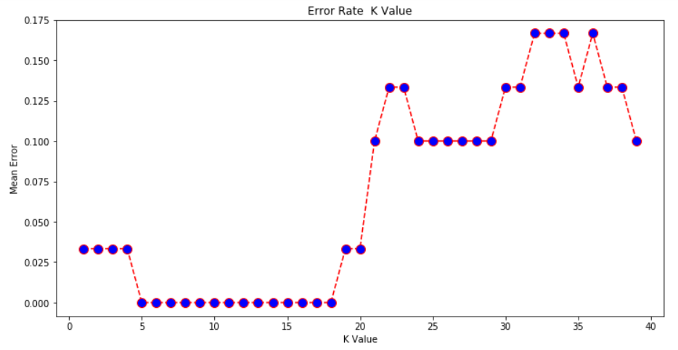

From the output we can see that the mean error is zero when the value of the K is between 5 and 18. I would advise you to play around with the value of K to see how it impacts the accuracy of the predictions.